**Name: Diksha**

**Student ID: 0794012**

SURVEY LINK: <https://forms.gle/su4nYHMpG1jvcajz8>

**Step 1: Survey Trials**

**Raw Response:**

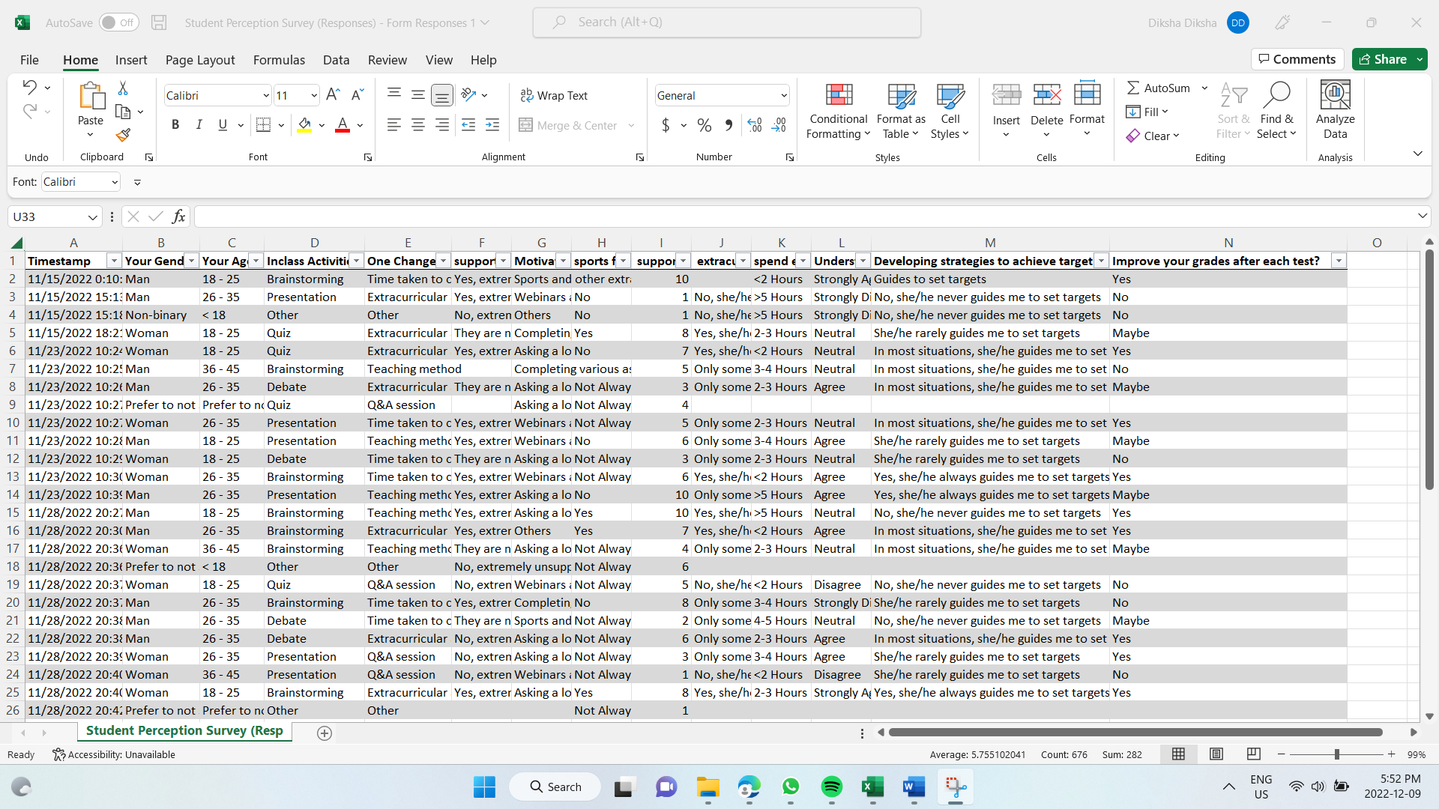

Raw Data collected after survey

**Step 2: After Cleaning**

**Cleaning Steps:**

* Removed the survey timestamp column
* Removed blank records in columns
* Removed null values
* Kept only 45 records for analysis after data cleaning
* Renaming long column names

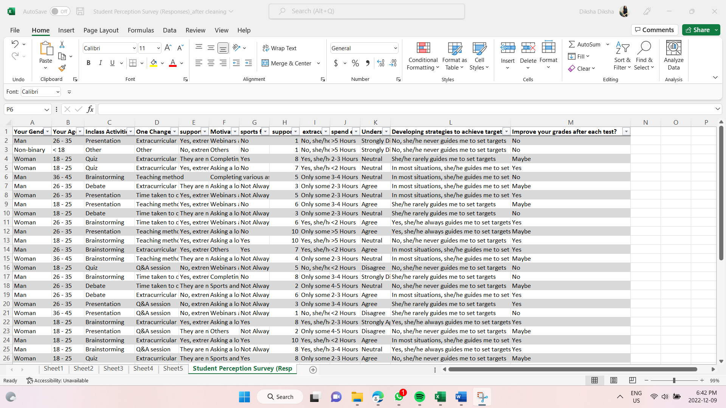

Cleaned dataset for Reporting and Dashboard

**Dashboard Analysis 1**

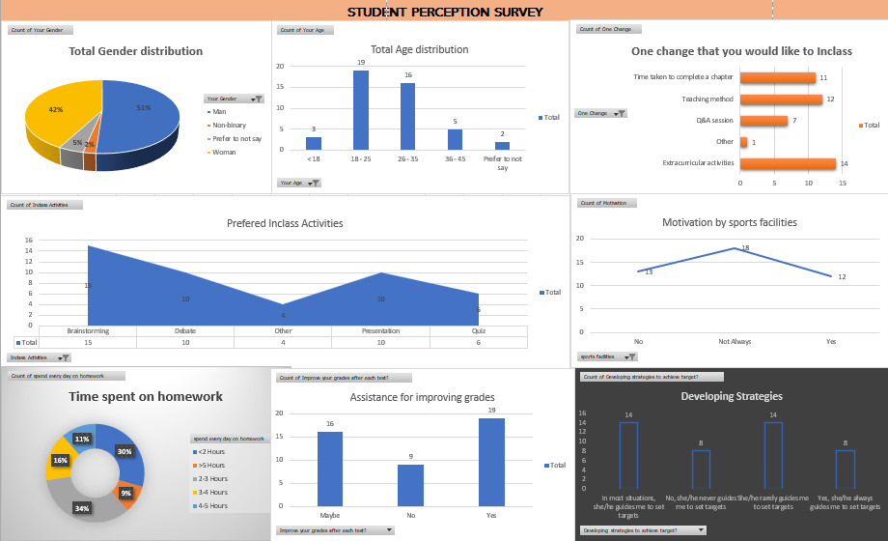

**Analysis from Dashboard 1:**

* Most of the survey takers were in the age bracket of **18-34**, out of that **25-34 age group had the highest number** of survey participants.
* In terms of Demographic, the highest number of the survey was given by males at 51%
* Given a chance, students will like to change the **“Extracurricular activities”** the most in the in-class activities.
* **44.7%** of students said the school doesn’t provide them with adequate sports facilities.
* Most of the students agreed **that teachers appreciate the times when you work hard** towards scoring well on a test or performing well in extracurricular activities.
* 32.7% of students choose “**Brainstorming**” activities in the classroom do you enjoy the most
* 34% of the students spent 2-3hours every day on homework.

**Dashboard Analysis 2**

**Analysis from Dashboard 2:**

* 52% of students agreed that they have “**Extremely supportive classmates**”
* 37% of the students agreed with this statement: “**My teachers ask each of us whether we have understood what she taught and helps us in case we have doubts.”**
* **“Webinars and Job fairs”** were mostly preferred among students to motivate them to learn.

**Survey link:** <https://forms.gle/su4nYHMpG1jvcajz8>